9.53-8th Main question Overdamp

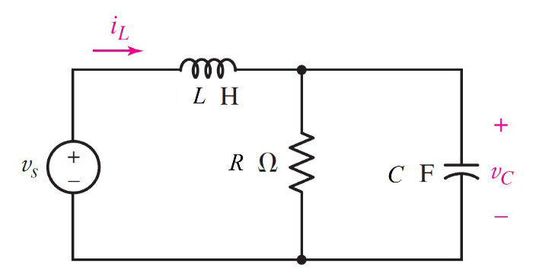

Given vs = 1- 2*u(t) A*, r= 500 mΩ, c = 0.5 *m*F, l= 6 mH

Find Overdamp

Variables

Random variables

#l < 4*r*r*c Parallel, c < 4*r*r/l Series

r = {0.1:0.5:0.1};

c = {0.1e-3:0.5e-3:0.1e-3};

l = {0.001:0.006;0.001};

Global variables

#vs0n = 1;vs0p = -1; r1 = 0.3; c = 0.5e-3;

l = 6e-3; time = 0.004;

# t = 0-

il0 = vs0n/r;

vc0 = vs0n;

# t = ∞

vcf = vs0p;

ilf = vs0p/r;

# t = 0+

rth = r;

alpha = 1/(2*rth*c);

w0 = 1/sqrt(l*c);

S1 = -alpha+sqrt(alpha*alpha-w0*w0);

S2 = -alpha-sqrt(alpha*alpha-w0*w0);

ir = vc0/r;

ico = -il0-ir;

A1 = ((ic0/c)-(S2*(vc0-vcf)))/(S1-S2);

A2 = vc0-vcf-A1;

vct = vcf+A1exp(S1*time)+A2exp(S2*time);

Part (กรอกคำตอบ)

1. *vc*(0-) = vc0 = 1 V

2. *vc*(∞) = vcf = -1V

3. *α* = alpha = 200 s^-1

4. *ω*0 = w0 = 182.57 rad/s

At *t* > 0

5. *vc*(*t*) = vcf+A1exp(S1*t)+A2exp(S2*t)

= -1+3.449exp(-118.34*t) – 1.4492exp(-281.65*t) V

6. *vc*(time*τ*) = vct = 0.679 V

9.55-8th Main question Overdamp

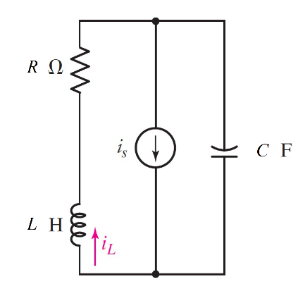

Given Is = 5 *u(-t)-4 mA*, r= 1000 Ω, c = 20 nF, l= 2 mH

Find

Variables

Random variables

#l < 4*r*r*c Parallel, c < 4*r*r/l Series

r = {1000:2000:100};

l = {0.0005:0.002:0.0005};

c = {0.02e-6:0.05e-6:0.01e-6};

Global variables

#is0n = -4e-3; is0p = 1e-3; r = 1000; c = 20e-9;

l = 0.002; time = 0.000

1;

# t = 0-

il0 = is0n;

v0 = -is0n*r;

# t = ∞

vcf = -is0p*r;

ilf = is0p;

# t = 0+

rth = r;

alpha = R/(2*L);

w0 = 1/sqrt(l*c);

S1 = -alpha+sqrt(alpha*alpha-w0*w0);

S2 = -alpha-sqrt(alpha*alpha-w0*w0);

vr= il0/r;

vl0=vc0-vr;

A1 = ((vl0/l)-(S2*(il0-ilf)))/(S1-S2);

A2 = il0-ilf-A1;

ilt = ilf+A1exp(S1*time)+A2exp(S2*time);

Part (กรอกคำตอบ)

1. *iL*(0-) = il0 = -4 mA

2. *vc*(∞) = ilf = -1 mA

3. *α* = alpha = 250000 s^-1

4. *ω*0 = w0 = 158113.8 rad/s

At *t* > 0

5. *vc*(*t*) = ilf+A1exp(S1*t)+A2exp(S2*t)

= 1+4.6exp(-56350*t) – 9.6exp(-443650*t) mV

6. *vc*(time*τ*) = vct = 1.016425 mV

9.57-8th Main question underdamp

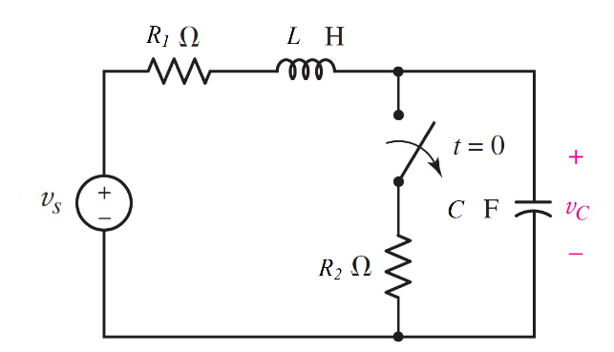

Given vs = 6 , r1= 100 mΩ, r2= 200 mΩ, c = 0.5F, l= 0.01 H Find

Variables

Random variables

#l < 4*r*r*c Parallel, c < 4*r*r/l Series

vs = {1:6};

r1 = {0.1:0.5;0.1};

r2 = {0.1:0.5;0.1};

l = {0.01:0.03:0.01};

c = {0.1:0.5:0.1};

Global variables

#vs = 6; r1 = 0.1; r2 = 0.2; c = 0.5;

l = 0.01; time = 1;

# t = 0-

il0 = vs/(r1+r2);

vc0 = (r1/(r1+r2)) * vs;

# t = ∞

vcf = vs;

ilf = 0;

# t = 0+

rth = r1;

alpha = 1/(2*rth*c);

w0 = 1/sqrt(l*c);

wd = sqrt(w0*w0-alpha*alpha);

vr=il0*r;

vl0=vs-vc0-vr;

A1 = il0;

A2 = (vl0/l+alpha*A1)/wd;

ilt = ilf+(A1*cos(wd*time) + A2*sin(wd*time))exp(-alpha*time);

Part (กรอกคำตอบ)

1. *iL*(0-) = il0 = 20A
2. *vc*(0-) = vc0 = 4 V
3. *iL*(∞) = ilf = 0 A
4. *α* = alpha = 5 s^-1
5. *ω*0 = w0 = 14.14 rad/s

At *t* > 0

1. *iL*(*t*) = ilf+(A1*cos(wd*t) + A2*sin(wd*t))exp(-alpha*t)

= (20*cos(13.226*t) + 7.56*sin(13.226*t))exp(-5*t) V

1. *iL*(time*τ*) = vct = 0.1377 V

9.58-8th Main question underdamp

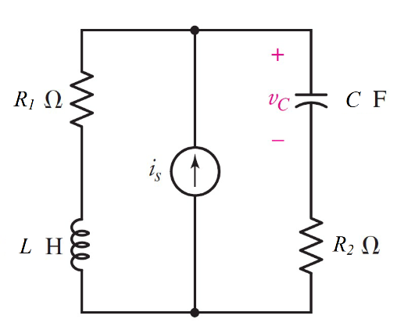

Given Is = 3 *u(-t)* +5 *u(t) mA*, r1= 3 Ω, r2= 10 Ω, c = 4 µF, l= 2 mH Find

Variables

Random variables

#l < 4*r*r*c Parallel, c < 4*r*r/l Series

r1 = {1:5:};

r2 = {1:10:};

l = {1e-3:3e-3:0.5e-3};

c = {2e-6:4e-6:1e-6};

Global variables

#is0n = 3e-3; is0p = 5e-3; r1 = 3; r2 = 10, c = 4e-6;

l = 0.002; time = 0.001;

# t = 0-

il0 = is0n;

vc0 = -is0n*r1;

# t = ∞

ilf = is0p;

vcf = -is0p*3;

# t = 0+

rth = r1+r2;

alpha = rth/2*l;

w0 = 1/sqrt(l*c);

wd = sqrt(w0*w0-alpha*alpha);

ic=is0p-il0;

A1 = vc0;

A2 = (ic0/c+alpha*A1)/wd;

vlt = vlf+(A1*cos(wd*time) + A2*sin(wd*time))exp(-alpha*time);

Part (กรอกคำตอบ)

1. *iL*(0-) = il0 = 3 mA
2. *vc*(0-) = vc0 = -9 mV
3. *iL*(∞) = ilf = 5 mA
4. *α* = alpha = 3250 s^-1
5. *ω*0 = w0 = 11180 rad/s

At *t* > 0

1. *iL*(*t*) = ilf+(A1*cos(wd*t) + A2*sin(wd*t))exp(-alpha*t)

= -0.015+(0.006*cos(10697*t) + 0.048*sin(10697*t))exp(-3250*t) V

1. *iL*(time*τ*) = vct = -0.01684 V

9.61 7th Main question Critical damping

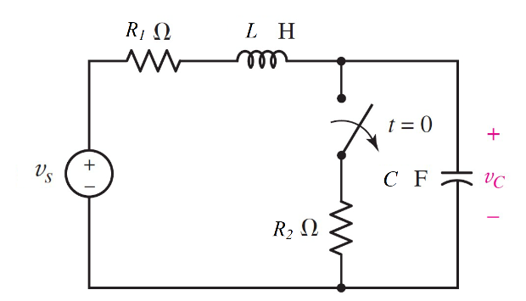

Given vs = 12 V, r1= 1, r2= 5 Ω, c = 2F, l= 0.5H,

Find

Variables

Random variables

#l < 4*r*r*c Parallel, c < 4*r*r/l Series

is = {0.01:0.05:0.01};

vc0 = {5:10:1};

r2 = {1:5:1};

c = {50e-6:200e-5:50e-5};

l = {0.01:0.05:0.01};

Global variables

#r1=1; r2 = 5; c = 2;

l = 0.5; vs=6;time = 0.001;

# t = 0-

Vc0=(r2/(r1+r2))*vs;

il0 = vs/(r1+r2);

# t = ∞

vcf = vs;

# t = 0+

rth = r1;

alpha = 1/(2*rth*c);

w0 = alpha;

ico = il0;

A2 = vc0-vcf;

A1 = ic/c + alpha*A2;

vct = vcf+(A1*time+A2)exp(alpha*time);

Part (กรอกคำตอบ)

1. *vc*(0-) = vc0 = 10 V
2. *iL*(0+) = il0 = 2A
3. *vc*(∞) = vcf = 12 V
4. *α* = alpha = 1 s^-1
5. *ω*0 = w0 = 1 rad/s

At *t* > 0

1. *vc*(*t*) = vcf+(A1*t+A2)exp(-alpha*t)

= 12+(-1*t+2)exp(-1*t)

1. 6. *vc*(time*τ*) = vct = 13.974 V